**VATSIM EAST AFRICA**

**STANDARD OPERATING PROCEDURES**

SYSTEM AND PROCEDURES FOR PROVISION OF AIR TRAFFIC SERVICES IN TANZANIA

**AIR TRAFFIC SERVICES**

The Air Traffic Control services shall be provided to accomplish the following objectives:

1. Prevent collision between aircrafts
2. Prevent collision between aircrafts on the maneuvering area and obstructions on that are
3. Expedite and maintain the orderly flow of air traffic

The need of provision of Air Traffic Services shall be determined by considering the following

1. Types of air traffic involved
2. Density of air traffic
3. Meteorological condition
4. Such other factors as it may be relevant
5. Provide advice and information useful for the safe and efficient conduct of flights

**DIVISION OF AIRSPACE**

The Tanzanian Airspace constitutes one flight information region, within the region, the airspace below flight level 245 is known as a lower flight information region and that above as an upper flight information region.

**Airspace classification in Tanzania (Dar es salaam FIR)**

The Dar es Salaam FIR airspace has been classified as follows:

1. Class A:

* All airspace above FL245;
* All airspace above FL145 within the Dar es Salaam and Kilimanjaro TMAs
* All ATS routes in the upper and lower airspace.

b) Class D:

* TMAs: - Dar es Salaam and Kilimanjaro;
* Control Zones: - Dar es Salaam, Dodoma, Kilimanjaro, Mwanza and Zanzibar.
* Aerodrome traffic circuit at all TCAA manned aerodromes.

***Note:*** *VFR flights are not permitted above FL145.*

c) Class G:

All airspace below FL245 (outside the published ATS routes, published TMAs and CTRs).

***Note:*** *The following classes have not been established: B, C, E and F*

**Flight Rules within Tanzania**

Flights by civil aircraft within Tanzania airspace can only be conducted according to either visual flight rules (VFR) or instrument flight rules (IFR). These rules are contained in the Civil Aviation (Rules of the Air) Regulations, 2017 and (Air Traffic Services) Regulations, 2017.

A pilot must fly according to the IFR

* if the airspace has been notified as one which permits only IFR flights;
* if the meteorological conditions preclude VFR flights;
* at night, except when authorized to fly under Special VFR in a control zone;
* if intends to operate above FL 145.

**Visual Flight Rules (VFR)**

* The pilot of an aircraft is responsible for determining whether or not meteorological conditions permit flight in accordance with visual flight rules.
* Under VFR a pilot is responsible for avoiding collision with other aircraft and for the safe conduct of his flight generally. Except within the traffic zone of an aerodrome and any other area within which special rules may apply, he is not subject to ATC clearance or instructions. Pilots are subject to general flight rules, however, regardless of weather conditions.
* Different regulations apply dependent upon whether the aircraft is to be operated in or outside controlled airspace.
* VMC visibility and distance from cloud

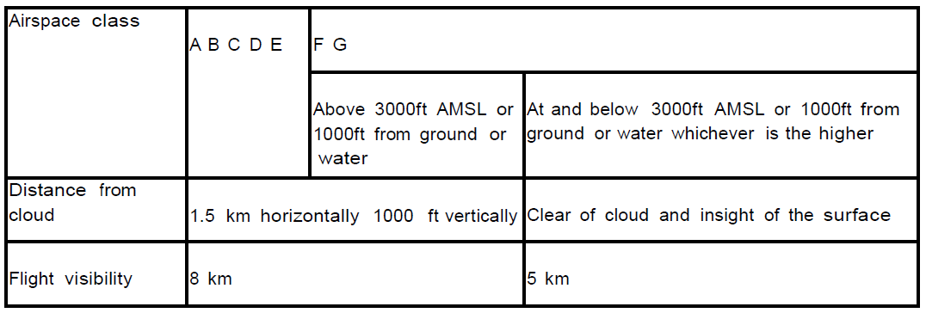

**Note1: -**

a) lower flight visibilities to 1.5 km may be permitted for flights operating:

* At speeds that, in the prevailing visibility, will give adequate opportunity to observe other traffic or any obstacles in time to avoid collision; or
* In circumstances in which the probability of encounters with other traffic would normally below, e.g. In areas of low volume traffic and aerial work at low levels.

b) Helicopters may be permitted to operate in less than 1.5 km flight visibility, if maneuvered at a speed that will give adequate opportunity to observe other traffic or any obstacles in time to avoid collision.

**Note2: -**

In Tanzania the Conditions for VFR operations apply in classes D and G

* 1. An aircraft operating under VFR in level cruising flight at a height of more than 1000 ft above ground or water, but less than flight level 150 shall, in the interests of safety fly in accordance with the semi-circular rule. The application of the semi-circular rule to VFR flight is illustrated below:
* 000 - 179 degrees inclusive: FL 35, 55, 75, etc.
* 180 - 359 degrees inclusive: FL 45, 65, 85, etc.
  1. Note: Within the Dar es Salaam Flight Information Region VFR flight is not permitted above flight level 145.
  2. VFR flight shall neither take-off nor land at an aerodrome within a control zone, nor enter the aerodrome traffic zone or the traffic pattern of such an aerodrome if the ground visibility is less than 8 km and/or the ceiling is less than 1500 feet.
  3. When meteorological conditions are below this minima all flights operating in the traffic zone of an aerodrome within a control zone must be conducted in accordance with ATC instructions and clearance.
  4. Notwithstanding paragraphs 2.5.4 above an aircraft may not be operated under VFR at night irrespective of weather conditions either in or outside controlled airspace except when authorized to fly under special VFR in a control zone.
  5. Note: An exemption to the above will be considered on application to the Tanzania
  6. Civil Aviation Authority, to enable pilots to carry out training for ―Night Ratings

**Instrument Flight rules (IFR)**

The instrument flight rules require a pilot to observe the minimum height rule and additional rules according to the type of airspace. The rules are summarized below.

Airspaces Classes A and D

1. file a flight plan and obtain a clearance before proceeding with the flight;
2. conduct the flight in accordance with clearances and instructions from air traffic control;
3. maintain a listening watch on the appropriate radio frequencies;
4. report the position of the aircraft according to published procedures;
5. comply with the notified communication failure procedures;
6. the pilot of the aircraft must be the holder of a license which includes an instrument rating;
7. the aircraft must be properly equipped.

Airspace Class G

Comply with the semi-circular rule when in level flight at or above a height of 1000ft above mean sea level. The altimeter is set to 1013.2hPa and the cruising level is selected according to the magnetic track unless the aircraft is holding according to the published procedures or is otherwise instructed by air traffic control.

Semi-circular Rule

1. Magnetic Tracks: 000º - 179º inclusive

Cruising Levels: FL 10, 30, 50, 70, 270, 290, 310, 330, to 410

1. Magnetic Tracks: 180º - 359º inclusive

Cruising Levels: FL 20, 40, 60, 80, … 280, 300, 320, 340, … to 400

Semi-circular Rule above FL 410 (above RVSM airspace):

1. Magnetic Tracks: 000º - 179º inclusive FL 450, 490, 530, 570, …
2. Magnetic Tracks: 180º - 359º inclusive FL 430, 470, 510, 550, …

Aerodrome Traffic Zones

1. Aerodrome traffic zones have not been allocated a specific class of airspace. They adopt the class of airspace within which they are situated. Aircraft flying within aerodrome traffic zones are, however, subject to the rules of the air in addition to the specific conditions of the airspace.
2. At aerodromes with an air traffic control unit, all movements are subject to the permission of that unit. Aircraft will comply with instructions given by radiotelephone and maintain a listening watch. Non-radio aircraft, which have been given prior permission to fly within the zone, will comply with visual signals.
3. Controllers are to provide an air traffic control service to aircraft within an aerodrome traffic zone and to aircraft under their jurisdiction in the vicinity of the aerodrome.

Cancellation of IFR flight

1. IFR flight plans shall only be cancelled when the pilot uses the expression ―cancelling my IFR flight. Pilots must not be invited to cancel but if there is any doubt of the pilot’s intentions he may be asked if he wishes to cancel his IFR flight plan.
2. Controllers are to acknowledge a cancellation using the phrase ―IFR flight cancelled at...(time).
3. Pilots canceling IFR plans shall be given any information which indicates that IMC may been encountered along the intended route.

Suspension of VFR operations

1. Any or all visual flight rules (VFR) operations on and in the vicinity of an aerodrome may be suspended by any of the following units, persons or authorities whenever safety requires such action:

* The approach control unit or appropriate area control center;
* The aerodrome control tower;

1. All such suspensions of VFR operations shall be accomplished through or notified to the aerodrome control tower.
2. The following procedures shall be observed by the aerodrome control tower whenever VFR operations are suspended:

* hold all VFR departures;
* recall all local flights operating under VFR or obtain approval for special VFR operations;
* notify the approach control unit or area control center as appropriate of the action taken;
* notify all operators, or their designated representatives, of the reason for taking such action if necessary or requested.

Special VFR flight

A special VFR flight is a VFR flight carried out in instrument meteorological conditions or at night in a control zone, which cannot comply with the instrument flight rules but is conducted in accordance with special instructions given by the ATS unit.

1. The pilot of an aircraft on a Special VFR flight:

must comply with ATC instructions;

* is responsible for ensuring that his flight conditions enable him to remain clear of cloud, determine his flight path with reference to the surface and keep clear of obstructions;
* is responsible for ensuring that he flies within the limitations of his license;
* is responsible for complying with the low flying rules.

1. Normally a Special VFR clearance is issued when requested by a pilot. Before issuing the clearance, a controller must consider prevailing traffic conditions, the extent of the proposed flight and the availability of air/ground communications. IFR flights take precedence over Special VFR flights.
2. Standard separation is to be applied:

* between IFR and Special VFR flights; and
* between aircraft cleared for Special VFR flights.

1. Aircraft are not normally given a specific height to fly but vertical separation from aircraft flying above can be achieved by requiring the Special VFR flight to fly not above a specified level.
2. Special VFR flight will not be authorized when the ground visibility is less than 1.5 km and/or the ceiling is less than 500feet.

Change from VFR flight to IFR flight

An aircraft operating in accordance with VFR, which wishes to change to IFR, shall comply with one of the following conditions:

1. if a flight plan was submitted, communicate whenever possible the necessary changes to be effected to its current flight plan to the appropriate ATC unit;
2. submit a flight plan to the appropriate ATC unit and obtain a clearance prior to operating under IFR in controlled airspace;
3. continue to operate in accordance with VFR if unable to communicate with an ATC unit or obtain the necessary clearance for the flight within controlled airspace.